Madaline
Exercise 5: Implement a MADALINE-Based Heart Disease Classification and Adaptive Decision Analysis System using the Heart Disease Dataset

INPUT 1 — CODE
# ============================================================
# MADALINE-Based Heart Disease Classification and
# Adaptive Decision Analysis System
# Dataset: UCI Heart Disease Dataset
# ============================================================
import numpy as np
import pandas as pd
import matplotlib.pyplot as plt
from sklearn.model_selection import train_test_split
from sklearn.preprocessing import StandardScaler
from sklearn.metrics import (
accuracy_score,
classification_report,
confusion_matrix
)
# ============================================================
# 1. LOAD HEART DISEASE DATASET
# ============================================================
url = "https://archive.ics.uci.edu/ml/machine-learning-databases/heart-disease/processed.cleveland.data"
columns = [
"age",
"sex",
"cp",
"trestbps",
"chol",
"fbs",
"restecg",
"thalach",
"exang",
"oldpeak",
"slope",
"ca",
"thal",
"target"
]
df = pd.read_csv(
url,
names=columns,
na_values="?"
)
print("=" * 70)
print("MADALINE HEART DISEASE CLASSIFICATION SYSTEM")
print("=" * 70)
print("\nOriginal Dataset Shape:", df.shape)
print("\nFirst 5 Records:")
print(df.head())
# ============================================================
# 2. HANDLE MISSING VALUES
# ============================================================
print("\nMissing Values:")
print(df.isnull().sum())
df = df.dropna().reset_index(drop=True)
print("\nDataset Shape After Removing Missing Values:")
print(df.shape)
# ============================================================
# 3. CONVERT TARGET INTO BINARY CLASS
# ============================================================
# Original UCI target:
# 0 = No Heart Disease
# 1,2,3,4 = Heart Disease
#
# Convert:
# 0 -> 0
# >0 -> 1
df["target"] = np.where(
df["target"] > 0,
1,
0
)
print("\nTarget Distribution:")
print(df["target"].value_counts())
print("\nTarget Meaning:")
print("0 = No Heart Disease")
print("1 = Heart Disease")
# ============================================================
# 4. SEPARATE FEATURES AND TARGET
# ============================================================
X = df.drop(
columns=["target"]
)
y = df["target"].values
# ============================================================
# 5. TRAIN-TEST SPLIT
# ============================================================
X_train, X_test, y_train, y_test = train_test_split(
X,
y,
test_size=0.20,
random_state=42,
stratify=y
)
print("\nTraining Samples:", len(X_train))
print("Testing Samples :", len(X_test))
# ============================================================
# 6. FEATURE SCALING
# ============================================================
scaler = StandardScaler()
X_train = scaler.fit_transform(
X_train
)
X_test = scaler.transform(
X_test
)
# ============================================================
# 7. MADALINE CLASS
# ============================================================
class MADALINE:
def __init__(
self,
n_features,
n_hidden=8,
learning_rate=0.001,
epochs=100,
random_state=42
):
self.n_features = n_features
self.n_hidden = n_hidden
self.learning_rate = learning_rate
self.epochs = epochs
self.random_state = random_state
self.W1 = None
self.b1 = None
self.W2 = None
self.b2 = None
self.loss_history = []
self.initialize_weights()
# --------------------------------------------------------
# Initialize weights
# --------------------------------------------------------
def initialize_weights(self):
rng = np.random.RandomState(
self.random_state
)
self.W1 = rng.normal(
0,
0.1,
(
self.n_features,
self.n_hidden
)
)
self.b1 = np.zeros(
self.n_hidden
)
self.W2 = rng.normal(
0,
0.1,
self.n_hidden
)
self.b2 = 0.0
# --------------------------------------------------------
# Bipolar activation
# --------------------------------------------------------
def activation(self, x):
return np.where(
x >= 0,
1,
-1
)
# --------------------------------------------------------
# Forward propagation
# --------------------------------------------------------
def forward(self, X):
hidden_input = (
np.dot(
X,
self.W1
)
+ self.b1
)
hidden_output = self.activation(
hidden_input
)
output = (
np.dot(
hidden_output,
self.W2
)
+ self.b2
)
return (
hidden_input,
hidden_output,
output
)
# --------------------------------------------------------
# Training
# --------------------------------------------------------
def fit(self, X, y):
# Convert:
# 0 -> -1
# 1 -> +1
y_binary = np.where(
y == 1,
1,
-1
)
self.loss_history = []
for epoch in range(
self.epochs
):
total_error = 0
indices = np.random.permutation(
len(X)
)
X_shuffled = X[indices]
y_shuffled = y_binary[indices]
for xi, target in zip(
X_shuffled,
y_shuffled
):
# Forward pass
hidden_input = (
np.dot(
xi,
self.W1
)
+ self.b1
)
hidden_output = self.activation(
hidden_input
)
output = (
np.dot(
hidden_output,
self.W2
)
+ self.b2
)
# Calculate error
error = target - output
total_error += error ** 2
# Predicted class
predicted = (
1
if output >= 0
else -1
)
# ------------------------------------------------
# MADALINE adaptive update
# ------------------------------------------------
if predicted != target:
# Find neuron closest to decision boundary
neuron_index = np.argmin(
np.abs(
hidden_input
)
)
# Update selected hidden neuron
self.W1[:, neuron_index] += (
self.learning_rate
* error
* xi
)
self.b1[neuron_index] += (
self.learning_rate
* error
)
# Update output weight
self.W2[neuron_index] += (
self.learning_rate
* error
* hidden_output[
neuron_index
]
)
self.b2 += (
self.learning_rate
* error
)
mse = (
total_error
/ len(X)
)
self.loss_history.append(
mse
)
return self
# --------------------------------------------------------
# Decision score
# --------------------------------------------------------
def predict_score(self, X):
scores = []
for xi in X:
_, _, output = self.forward(
xi.reshape(1, -1)
)
scores.append(
output[0]
)
return np.array(
scores
)
# --------------------------------------------------------
# Prediction
# --------------------------------------------------------
def predict(self, X):
scores = self.predict_score(
X
)
return np.where(
scores >= 0,
1,
0
)
# ============================================================
# 8. CREATE MADALINE MODEL
# ============================================================
print("\n" + "=" * 70)
print("TRAINING MADALINE NETWORK")
print("=" * 70)
madaline = MADALINE(
n_features=X_train.shape[1],
n_hidden=8,
learning_rate=0.001,
epochs=100,
random_state=42
)
madaline.fit(
X_train,
y_train
)
print(
"\nMADALINE training completed successfully."
)
# ============================================================
# 9. PREDICTION
# ============================================================
y_pred = madaline.predict(
X_test
)
# ============================================================
# 10. ACCURACY
# ============================================================
accuracy = accuracy_score(
y_test,
y_pred
)
print("\n" + "=" * 70)
print("CLASSIFICATION RESULTS")
print("=" * 70)
print(
f"\nAccuracy: {accuracy * 100:.2f}%"
)
# ============================================================
# 11. CLASSIFICATION REPORT
# ============================================================
print("\nClassification Report:\n")
print(
classification_report(
y_test,
y_pred,
target_names=[
"No Heart Disease",
"Heart Disease"
]
)
)
# ============================================================
# 12. CONFUSION MATRIX
# ============================================================
cm = confusion_matrix(
y_test,
y_pred
)
print("\nConfusion Matrix:")
print(cm)
plt.figure(
figsize=(6, 5)
)
plt.imshow(
cm,
interpolation="nearest"
)
plt.title(
"MADALINE Confusion Matrix"
)
plt.colorbar()
plt.xticks(
[0, 1],
[
"No Disease",
"Disease"
]
)
plt.yticks(
[0, 1],
[
"No Disease",
"Disease"
]
)
plt.xlabel(
"Predicted"
)
plt.ylabel(
"Actual"
)
for i in range(2):
for j in range(2):
plt.text(
j,
i,
cm[i, j],
ha="center",
va="center"
)
plt.tight_layout()
plt.show()
# ============================================================
# 13. TRAINING LOSS
# ============================================================
plt.figure(
figsize=(9, 5)
)
plt.plot(
madaline.loss_history
)
plt.xlabel(
"Epoch"
)
plt.ylabel(
"Mean Squared Error"
)
plt.title(
"MADALINE Training Loss"
)
plt.grid(True)
plt.show()
# ============================================================
# 14. ADAPTIVE LEARNING RATE ANALYSIS
# ============================================================
print("\n" + "=" * 70)
print("ADAPTIVE LEARNING RATE ANALYSIS")
print("=" * 70)
learning_rates = [
0.0001,
0.0005,
0.001,
0.005,
0.01
]
adaptive_results = []
for lr in learning_rates:
print(
f"\nTesting Learning Rate: {lr}"
)
model = MADALINE(
n_features=X_train.shape[1],
n_hidden=8,
learning_rate=lr,
epochs=100,
random_state=42
)
model.fit(
X_train,
y_train
)
predictions = model.predict(
X_test
)
acc = accuracy_score(
y_test,
predictions
)
adaptive_results.append({
"Learning Rate": lr,
"Accuracy (%)": acc * 100,
"Final Loss": model.loss_history[-1]
})
adaptive_df = pd.DataFrame(
adaptive_results
)
print("\nLearning Rate Results:")
print(
adaptive_df.to_string(
index=False
)
)
# ============================================================
# 15. BEST LEARNING RATE
# ============================================================
best_index = adaptive_df[
"Accuracy (%)"
].idxmax()
best_learning_rate = adaptive_df.loc[
best_index,
"Learning Rate"
]
best_accuracy = adaptive_df.loc[
best_index,
"Accuracy (%)"
]
print(
f"\nBest Learning Rate: "
f"{best_learning_rate}"
)
print(
f"Best Accuracy: "
f"{best_accuracy:.2f}%"
)
# ============================================================
# 16. ADAPTIVE DECISION ANALYSIS
# ============================================================
print("\n" + "=" * 70)
print("ADAPTIVE DECISION ANALYSIS")
print("=" * 70)
scores = madaline.predict_score(
X_test
)
decision_table = pd.DataFrame({
"Actual": y_test,
"Predicted": y_pred,
"Decision Score": scores
})
decision_table["Actual Label"] = (
decision_table["Actual"]
.map({
0: "No Disease",
1: "Heart Disease"
})
)
decision_table["Predicted Label"] = (
decision_table["Predicted"]
.map({
0: "No Disease",
1: "Heart Disease"
})
)
print(
decision_table[
[
"Actual Label",
"Predicted Label",
"Decision Score"
]
].head(15)
)
# ============================================================
# 17. DECISION STRENGTH
# ============================================================
decision_table["Decision Strength"] = (
np.abs(
decision_table["Decision Score"]
)
)
print("\nDecision Strength Statistics:")
print(
decision_table[
"Decision Strength"
].describe()
)
# ============================================================
# 18. LOW-CONFIDENCE SAMPLE DETECTOR
# ============================================================
threshold = np.percentile(
decision_table["Decision Strength"],
25
)
low_confidence = decision_table[
decision_table["Decision Strength"]
<= threshold
]
print("\n" + "=" * 70)
print("LOW-CONFIDENCE DECISION ANALYSIS")
print("=" * 70)
print(
f"\nLow-confidence threshold: "
f"{threshold:.4f}"
)
print(
f"Low-confidence samples: "
f"{len(low_confidence)}"
)
print(
low_confidence[
[
"Actual Label",
"Predicted Label",
"Decision Score",
"Decision Strength"
]
].head(10)
)
# ============================================================
# 19. MISCLASSIFICATION ANALYSIS
# ============================================================
misclassified = decision_table[
decision_table["Actual"]
!=
decision_table["Predicted"]
]
print("\n" + "=" * 70)
print("MISCLASSIFICATION ANALYSIS")
print("=" * 70)
print(
f"\nTotal Test Samples: {len(y_test)}"
)
print(
f"Misclassified Samples: "
f"{len(misclassified)}"
)
print(
f"Misclassification Rate: "
f"{len(misclassified) / len(y_test) * 100:.2f}%"
)
if len(misclassified) > 0:
print("\nMisclassified Samples:")
print(
misclassified[
[
"Actual Label",
"Predicted Label",
"Decision Score"
]
].head(15)
)
# ============================================================
# 20. FEATURE SENSITIVITY ANALYSIS
# ============================================================
print("\n" + "=" * 70)
print("FEATURE SENSITIVITY ANALYSIS")
print("=" * 70)
feature_importance = np.sum(
np.abs(
madaline.W1
*
madaline.W2
),
axis=1
)
feature_analysis = pd.DataFrame({
"Feature": columns[:-1],
"Sensitivity": feature_importance
})
feature_analysis = feature_analysis.sort_values(
by="Sensitivity",
ascending=False
)
print(
feature_analysis.to_string(
index=False
)
)
# ============================================================
# 21. FEATURE SENSITIVITY PLOT
# ============================================================
plt.figure(
figsize=(10, 6)
)
plt.barh(
feature_analysis["Feature"],
feature_analysis["Sensitivity"]
)
plt.xlabel(
"Sensitivity Score"
)
plt.ylabel(
"Feature"
)
plt.title(
"MADALINE Feature Sensitivity Analysis"
)
plt.gca().invert_yaxis()
plt.tight_layout()
plt.show()
# ============================================================
# 22. NEW PATIENT PREDICTION
# ============================================================
def predict_heart_disease(
age,
sex,
cp,
trestbps,
chol,
fbs,
restecg,
thalach,
exang,
oldpeak,
slope,
ca,
thal
):
sample = np.array([
[
age,
sex,
cp,
trestbps,
chol,
fbs,
restecg,
thalach,
exang,
oldpeak,
slope,
ca,
thal
]
])
sample_scaled = scaler.transform(
sample
)
score = madaline.predict_score(
sample_scaled
)[0]
prediction = (
1 if score >= 0
else 0
)
print("\n" + "=" * 60)
print("HEART DISEASE PREDICTION")
print("=" * 60)
print(
"\nDecision Score:",
round(score, 4)
)
if prediction == 1:
print(
"Prediction: Heart Disease"
)
else:
print(
"Prediction: No Heart Disease"
)
print(
"\nNote: This is an educational ML prediction, "
"not a medical diagnosis."
)
return prediction
# ============================================================
# 23. SAMPLE PATIENT
# ============================================================
print("\n" + "=" * 70)
print("SAMPLE PATIENT PREDICTION")
print("=" * 70)
predict_heart_disease(
age=55,
sex=1,
cp=1,
trestbps=140,
chol=250,
fbs=0,
restecg=1,
thalach=150,
exang=0,
oldpeak=1.0,
slope=1,
ca=0,
thal=2
)
# ============================================================
# 24. FINAL SUMMARY
# ============================================================
print("\n" + "=" * 70)
print("FINAL MADALINE SYSTEM SUMMARY")
print("=" * 70)
print(
f"""
Dataset : UCI Heart Disease Dataset
Total Samples : {len(df)}
Input Features : {X.shape[1]}
Training Samples : {len(X_train)}
Testing Samples : {len(X_test)}
Hidden Neurons : 8
Initial Learning Rate : 0.001
Best Learning Rate : {best_learning_rate}
Best Accuracy : {best_accuracy:.2f}%
Algorithm:
MADALINE (Multiple ADALINE)
Implemented:
1. Heart Disease Classification
2. Adaptive Learning Rate Analysis
3. Decision Score Analysis
4. Low-Confidence Detection
5. Misclassification Analysis
6. Feature Sensitivity Analysis
7. New Patient Prediction
"""
)
print(
"\nMADALINE-based Heart Disease Classification "
"System completed successfully."
)

OUTPUT 1
======================================================================
MADALINE HEART DISEASE CLASSIFICATION SYSTEM
======================================================================
Original Dataset Shape: (303, 14)
First 5 Records:
age sex cp trestbps chol fbs restecg thalach exang oldpeak \
0 63.0 1.0 1.0 145.0 233.0 1.0 2.0 150.0 0.0 2.3
1 67.0 1.0 4.0 160.0 286.0 0.0 2.0 108.0 1.0 1.5
2 67.0 1.0 4.0 120.0 229.0 0.0 2.0 129.0 1.0 2.6
3 37.0 1.0 3.0 130.0 250.0 0.0 0.0 187.0 0.0 3.5
4 41.0 0.0 2.0 130.0 204.0 0.0 2.0 172.0 0.0 1.4
slope ca thal target
0 3.0 0.0 6.0 0
1 2.0 3.0 3.0 2
2 2.0 2.0 7.0 1
3 3.0 0.0 3.0 0
4 1.0 0.0 3.0 0
Missing Values:
age 0
sex 0
cp 0
trestbps 0
chol 0
fbs 0
restecg 0
thalach 0
exang 0
oldpeak 0
slope 0
ca 4
thal 2
target 0
dtype: int64
Dataset Shape After Removing Missing Values:
(297, 14)
Target Distribution:
target
0 160
1 137
Name: count, dtype: int64
Target Meaning:
0 = No Heart Disease
1 = Heart Disease
Training Samples: 237
Testing Samples : 60
======================================================================
TRAINING MADALINE NETWORK
======================================================================
MADALINE training completed successfully.
======================================================================
CLASSIFICATION RESULTS
======================================================================
Accuracy: 86.67%
Classification Report:
precision recall f1-score support
No Heart Disease 0.83 0.94 0.88 32
Heart Disease 0.92 0.79 0.85 28
accuracy 0.87 60
macro avg 0.88 0.86 0.86 60
weighted avg 0.87 0.87 0.87 60
Confusion Matrix:
[[30 2]
[ 6 22]]

OUTPUT 2
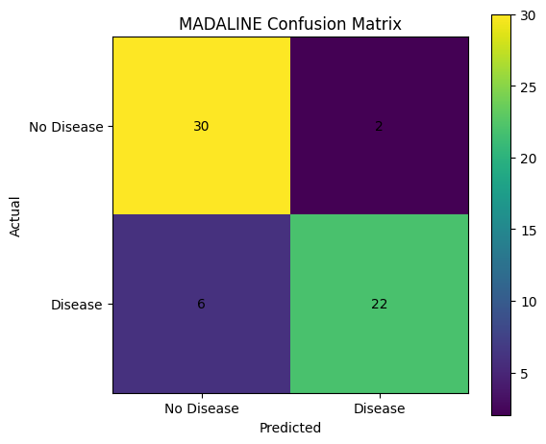

OUTPUT 3
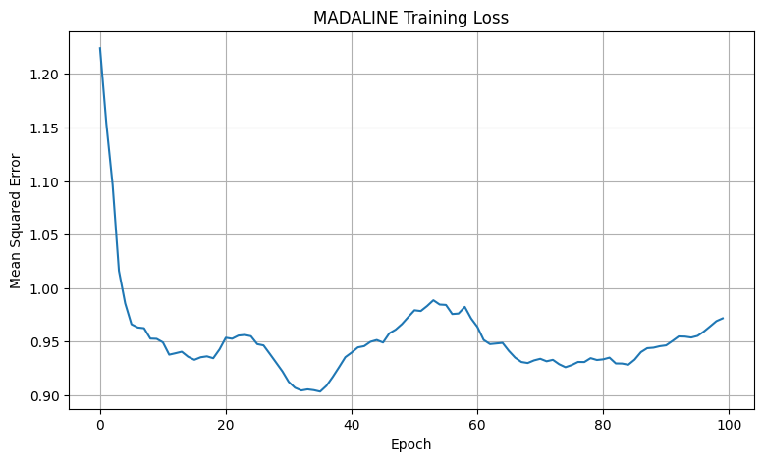

OUTPUT 4
======================================================================
ADAPTIVE LEARNING RATE ANALYSIS
======================================================================
Testing Learning Rate: 0.0001
Testing Learning Rate: 0.0005
Testing Learning Rate: 0.001
Testing Learning Rate: 0.005
Testing Learning Rate: 0.01
Learning Rate Results:
Learning Rate Accuracy (%) Final Loss
0.0001 76.666667 0.948020
0.0005 80.000000 0.982954
0.0010 83.333333 0.973406
0.0050 73.333333 0.943756
0.0100 76.666667 0.876713
Best Learning Rate: 0.001
Best Accuracy: 83.33%
======================================================================
ADAPTIVE DECISION ANALYSIS
======================================================================
Actual Label Predicted Label Decision Score
0 No Disease No Disease -0.048494
1 No Disease No Disease -0.002753
2 No Disease Heart Disease 0.018483
3 No Disease No Disease -0.002055
4 No Disease No Disease -0.000399
5 No Disease No Disease -0.032605
6 Heart Disease Heart Disease 0.007028
7 No Disease No Disease -0.046481
8 Heart Disease Heart Disease 0.034714
9 No Disease No Disease -0.031906
10 Heart Disease Heart Disease 0.038041
11 No Disease No Disease -0.032605
12 No Disease Heart Disease 0.006687
13 Heart Disease Heart Disease 0.022917
14 Heart Disease Heart Disease 0.003359
Decision Strength Statistics:
count 60.000000
mean 0.021573
std 0.014571
min 0.000399
25% 0.007763
50% 0.019500
75% 0.032605
max 0.048494
Name: Decision Strength, dtype: float64
======================================================================
LOW-CONFIDENCE DECISION ANALYSIS
======================================================================
Low-confidence threshold: 0.0078
Low-confidence samples: 15
Actual Label Predicted Label Decision Score Decision Strength
1 No Disease No Disease -0.002753 0.002753
3 No Disease No Disease -0.002055 0.002055
4 No Disease No Disease -0.000399 0.000399
6 Heart Disease Heart Disease 0.007028 0.007028
12 No Disease Heart Disease 0.006687 0.006687
14 Heart Disease Heart Disease 0.003359 0.003359
26 No Disease No Disease -0.002758 0.002758
35 Heart Disease Heart Disease 0.002594 0.002594
39 Heart Disease No Disease -0.002758 0.002758
43 Heart Disease No Disease -0.000883 0.000883
======================================================================
MISCLASSIFICATION ANALYSIS
======================================================================
Total Test Samples: 60
Misclassified Samples: 8
Misclassification Rate: 13.33%
Misclassified Samples:
Actual Label Predicted Label Decision Score
2 No Disease Heart Disease 0.018483
12 No Disease Heart Disease 0.006687
15 Heart Disease No Disease -0.031143
16 Heart Disease No Disease -0.012348
39 Heart Disease No Disease -0.002758
43 Heart Disease No Disease -0.000883
54 Heart Disease No Disease -0.002753
56 Heart Disease No Disease -0.002055
======================================================================
FEATURE SENSITIVITY ANALYSIS
======================================================================
Feature Sensitivity
cp 0.006300
thalach 0.005060
restecg 0.004994
slope 0.004596
sex 0.004587
trestbps 0.004467
oldpeak 0.004205
fbs 0.004000
ca 0.003340
age 0.002927
chol 0.002483
exang 0.002379
thal 0.001627

OUTPUT 5
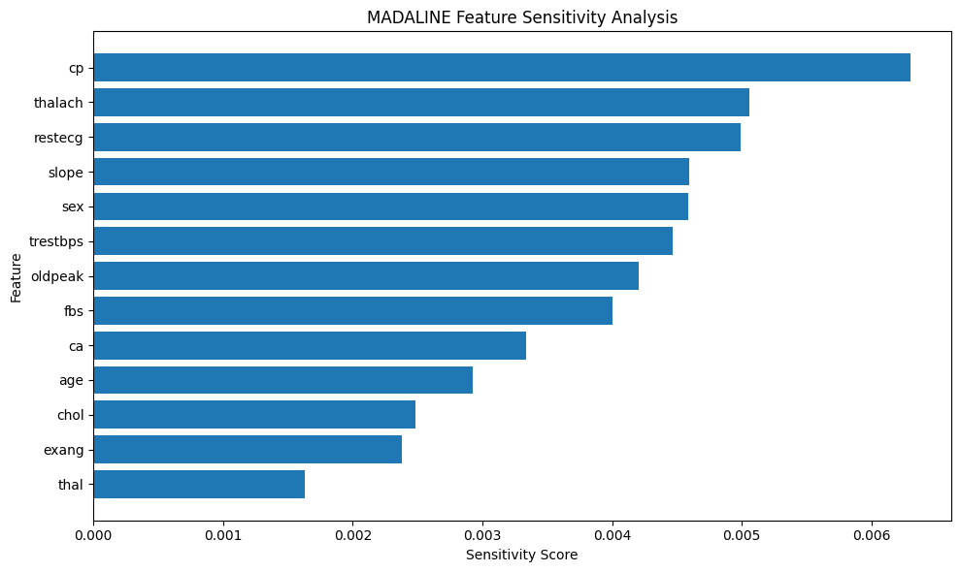

OUTPUT 6
======================================================================
SAMPLE PATIENT PREDICTION
======================================================================
============================================================
HEART DISEASE PREDICTION
============================================================
Decision Score: -0.0193
Prediction: No Heart Disease
Note: This is an educational ML prediction, not a medical diagnosis.
======================================================================
FINAL MADALINE SYSTEM SUMMARY
======================================================================
Dataset : UCI Heart Disease Dataset
Total Samples : 297
Input Features : 13
Training Samples : 237
Testing Samples : 60
Hidden Neurons : 8
Initial Learning Rate : 0.001
Best Learning Rate : 0.001
Best Accuracy : 83.33%
Algorithm:
MADALINE (Multiple ADALINE)
Implemented:
1. Heart Disease Classification
2. Adaptive Learning Rate Analysis
3. Decision Score Analysis
4. Low-Confidence Detection
5. Misclassification Analysis
6. Feature Sensitivity Analysis
7. New Patient Prediction
MADALINE-based Heart Disease Classification System completed successfully.

OUTPUT 7
/usr/local/lib/python3.13/dist-packages/sklearn/utils/validation.py:2739: UserWarning: X does not have valid feature names, but StandardScaler was fitted with feature names
warnings.warn(

